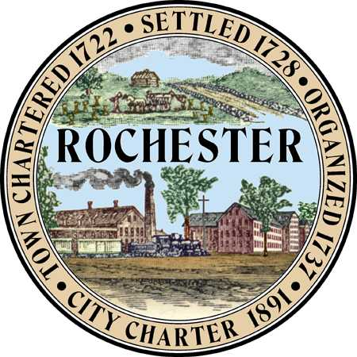
AGENDA

Rochester Conservation Commission

Meeting of May 27, 2015
6:30 P.M.

Police Department, Lecture Hall
(2nd floor via elevator)

Call to Order: Roll Call

Minutes: Review Meeting Minutes of April 22, 2015

- Discussion: None scheduled.

2. Conservation Overlay District: None scheduled.

3. Dredge and Fill Application/Wetland Permit Application: None scheduled.

4. Violations: None scheduled for discussion.

5. Correspondence: (emailed/sent prior to meeting):
a) Update on Laverdiere Farm NRCS grant application

6. Notice of Intent to Cut Wood or Timber / Intent to Excavate:
a) Notice of Intent to Cut - Tax Maps # 201-23&25, Tom Cusano, Spaulding Ave
b) Notice of Intent to Excavate- Tax Map# 207-1, Frank Torr, Route 11
c) Notice of Intent to Excavate- Tax Map#216-75, State of NH, Chestnut Hill Connector
d) Notice of Intent to Cut – Tax Map#206-7, Susan Steele, Chestnut Hill Rd/Channings Ln
e) Notice of Intent to Cut – Tax Map# 242-9, Andre Vanderzanden, Salmon Falls Rd/Haven Hill Rd

7. Reports: None scheduled.

8. Old Business: None scheduled.

- New Business: a) Discussion of Standard Operating Procedures

10. Other Business: None scheduled

11. Non-Public Session pursuant to RSA 91-A:3 II(d): Discussion of acquisition of real property and/or recent site walks and LACE sheets.

12. Adjournment:

