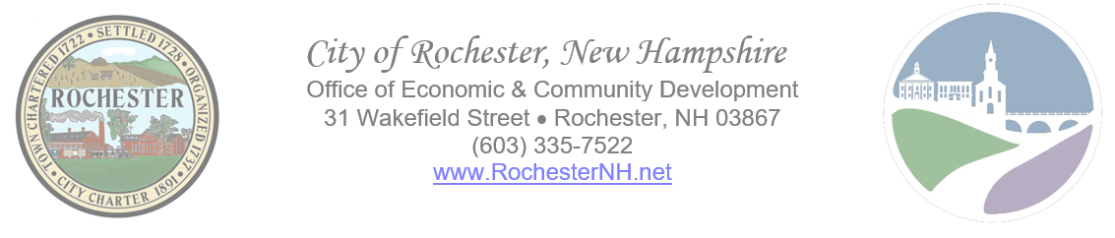
OVERVIEW

Remarque: Vous pouvez obtenir ce document en français gratuitement. S'il vous plaît contacter la Division du développement communautaire de la Ville de Rochester pour l'assistance.

Aviso: Puede obtener este documento en español de forma gratuita. Comuníquese con la División de Desarrollo Comunitario de la Ciudad de Rochester para obtener ayuda.

The Community Development Block Grant Entitlement Communities Grant Program (CDBG) provides annual grants on a formula basis to entitled cities and counties to develop viable communities by providing decent housing and a suitable living environment, and by expanding economic opportunities, principally for low and moderate income persons. The program is authorized under Title 1 of The Housing and Community Development Act of 1974, Public Law 93-383, as amended; 42 USC 5301. Program regulations are at 24 CFR 570.200.

The 2020 Coronavirus Aid, Relief, and Economic Security (CARES) Act provided additional federal funding allocations for the CDBG program. The City of Rochester’s CARES Act funds currently available are $17,887.78. The usual 15% cap on social services funding has been waived for the CARES Act funds.

Eligible Activities:
- Social services (e.g., homeless shelter services, mental health services, educational and vocational services, etc.)
- Physical projects
- Economic development activities that result in creation and/or retention of jobs
Project Beneficiaries: 51% of the individuals and/or families assisted by the program must earn very low, low, or moderate incomes (as determined by household income).

APPLICATION SUBMISSION INSTRUCTIONS

Applications will be accepted by email only. Applications are due by October 29, 2021 by 4:00 p.m.. Please submit your complete and signed application in PDF format to Julian Long, Community Development Coordinator, at julian.long@rochesternh.net.

Program Cover Sheet

Organization Name:
Tax ID #:
DUNS #:
Program Name:
Contact Person:
Email:
Mailing Address:
City, State, ZIP Code:
Physical Address of Program (if different from mailing address):
City, State, ZIP Code:
Phone:
Website:

1) Activity/Program Overview
- Does your proposed activity or program prevent, prepare for, or respond to the current COVID-19 pandemic?
  - No. YOU ARE NOT ELIGIBLE FOR CARES ACT CDBG FUNDING.
  - Yes. Provide a detailed description of how your proposed project or activity prevents, prepares for, or responds to the COVID-19 pandemic as it relates to serving low to moderate income residents. DO NOT SIMPLY STATE “GENERAL OPERATING EXPENSES.”
_________________________________________________________________________________________________________________________________________________________________________________________________________________________________________________________________________________________________________________
2) Program Costs and Other Funding Sources
- Rochester CDBG CARES Act grant request for FY 2022: $__________________
- Other COVID-19 funds available, anticipated, and/or applied for: _____________
_________________________________________________________________________
_________________________________________________________________________
3) Service Projection
- Total # of Rochester residents projected to be served with CDBG CARES Act grant funds? ______
- Total # of low/moderate income Rochester residents to be served with CBDG CARES Act grant funds? ____
- How does the agency determine income eligibility of clients? Please describe the documentation the agency collects/reviews to determine income eligibility. ______________________________________________________________________________________________________________________________________
4) Record Keeping
- Do you currently collect statistics regarding the race, ethnicity, income level, household size, and gender of your clients’ head of household? Yes No
5) Financial Statements
- Please include with your application an attachment with your organization’s most recent audit or other annual financial statement.

I certify that the information contained in this application is true and correct and that it contains no falsifications, misrepresentations, intentional omissions, or concealment of material facts.

I further certify that no contracts will be awarded, funds committed (including purchase or lease agreements), or construction begun on the proposed project prior to issuance of a release of funds by the City of Rochester.
I further certify that all agency clients who receive CARES Act funding will be required to return such funds in the case that a duplication of federal benefits is identified, per the Stafford Disaster Relief and Emergency Assistance;
I further certify that administration of any grant monies received shall be administered in compliance with all U.S. Department of Housing and Urban Development regulations, the anti-displacement policy of the City of Rochester, and the Uniform Relocation Assistance and Real Property Acquisition Policies Act of 1970 and its amendments.

Signature of Authorized Person | Date
Printed name and Title

