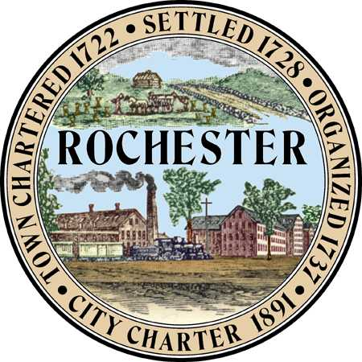
Planning & Development Department
Arts and Culture Commission
Matt Wyatt (Chair)
Eric Edema (Vice Chair)
Peter Ejarque
Elaine Lauterborn
Mike Provost
Amy Regan

City Hall - Second Floor
31 Wakefield Street,
Rochester, New Hampshire 03867-1917
(603) 335-1338 - Fax (603) 335-7585
Web Site: www.rochesternh.net

AGENDA
ARTS AND CULTURE COMMISSION
Thursday, October 15, 2015 at 7 pm
Canceled
City Council Conference Room
31 Wakefield Street, Rochester, NH
*see notes at end

