City of Rochester Dept of Public Works
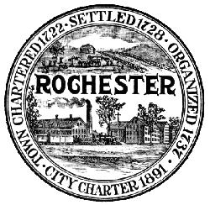Memo
45 Old Dover Road
Rochester, NH 03867
Phone: (603) 332-4096
Fax: (603) 335-4352
To: Public Works and Buildings Committee
From: Peter Nourse, PE
Date: July 10, 2014
Subject: Public Works and Buildings Committee
Meeting Thursday, July 17, 2014

There will be a Public Works and Buildings Committee Meeting on Thursday July 17, 2014 at 7:00 PM. This meeting will be held in Council Chambers, at City Hall.
AGENDA
- Approve Minutes from June 19, 2014 meeting
- Public Input
- Drainage Issues
- Utility Extension Policy
- New DPW Facility
- RFQ Consultant Process
- Summary of Summer Construction Activities
- Other

