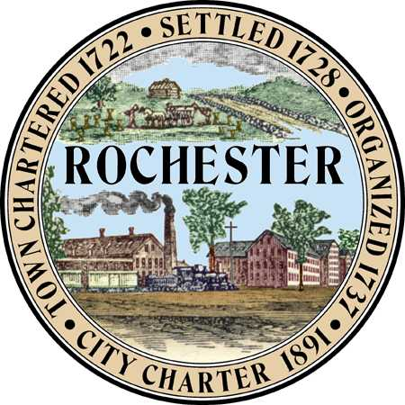
Planning & Development Department
Arts and Culture Commission
Matt Wyatt (Chair)
Eric Adema (Vice Chair)
Peter Ejarque
Elaine Lauterborn
Patricia O’Brian
Amy Regan
Mike Provost

City Hall - Second Floor
31 Wakefield Street,
Rochester, New Hampshire 03867-1917
(603) 335-1338 - Fax (603) 335-7585
Web Site: www.rochesternh.net

AGENDA
ARTS AND CULTURE COMMISSION
Thursday, June 18, 2015 at 7 pm
City Council Conference Room
31 Wakefield Street, Rochester, NH
*see notes at end
__________________________________________________________________________

Call to Order

Approval of minutes for May 21, 2015

Rochester Arts Awards Next Steps

Survey

Sidewalk Art Competition 7/18/15
  - Establish hours
  - Submitted permit application

Best of Rochester Next Steps

What is happening around Rochester?

Closing Remarks

Adjournment

********Next meeting is July 16, 2015

*Please note the following:
The public is invited to attend all meetings of the Arts and Culture Commission. Most meetings are not public hearings so the public may speak at the discretion of the chair/commission.

Contact the Planning and Development Department if you have questions or comments about these or any related matters or if you have a disability requiring special provisions.

