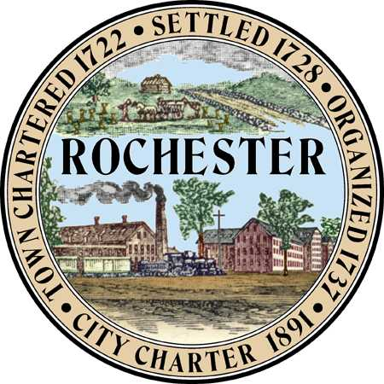
Planning & Development Department
Arts and Culture Commission
Matt Wyatt (Chair)
Eric Edema (Vice Chair)
Elaine Lauterborn
Mike Provost
Amy Regan

City Hall - Second Floor
31 Wakefield Street,
Rochester, New Hampshire 03867-1917
(603) 335-1338 - Fax (603) 335-7585
Web Site: www.rochesternh.net

AGENDA
ARTS AND CULTURE COMMISSION
Thursday, September 17, 2015 at 7:00 pm
City Council Conference Room
31 Wakefield Street, Rochester, NH
*see notes at end
__________________________________________________________________________

Call to Order

Approval of minutes for July 16, 2015

Rochester Art Awards Lessons Learned

Best of Rochester Next Steps

Police Department Steps (ideas for murals or design)

Courage Wall

Arts & Economic Prosperity Study

What is happening around Rochester?

Closing Remarks

Adjournment

********Next meeting October 15, 2015

*Please note the following:
The public is invited to attend all meetings of the Arts and Culture Commission. Most meetings are not public hearings so the public may speak at the discretion of the chair/commission.

Contact the Planning and Development Department if you have questions or comments about these or any related matters or if you have a disability requiring special provisions.

