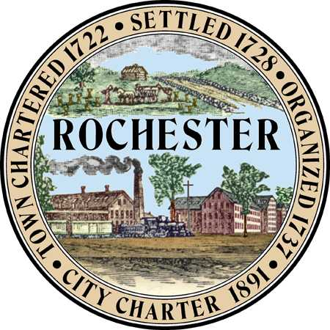
Arts and Culture Commission
Palana Hunt-Hawkins (Chair)
Ashley Desrochers (City Council Rep)
Kris Ebbeson
Ed Pacht (Poet Laureate)
Chloe White
Nicole Lee
Marie Lejune
Sarah Rowe
Olivia Miller

Planning & Development Department
City Hall Annex
33 Wakefield Street,
Rochester, New Hampshire 03867
(603) 335-1338
Web Site: https://www.rochesterarts.info/

Meeting Minutes
ARTS AND CULTURE COMMISSION
Wednesday, February 15, 2023 at 6:30 pm
Rochester Museum of Fine Arts – Rochester Community Center
150 Wakefield St

- Call to Order – Palana called the meeting to order at 630

- Roll Call – Shanna conducted silent roll call

- Membership – see if student interest

- Approval of minutes from December 13, 2022 – continued

- Historic and Cultural Master Plan – create a post card put downtown, library and rec center.

- Discussion about private partnerships for public art installs – allow but commission does not want the city to have to maintain. Grant proposal? Match funds? NH Council on Arts Grant to help fund. Draft grant application next year.

- Discussion on the Rochester Art Show potential – reach out to art awards. Prefer juried. Perhaps look into allowing Buskers with 1 hour timeslot. Try not to double book with Concert on the Commons on Wednesdays/Thurs (they have 8 slots). They pay between $400-$1000 per artist. We need to think about our budget. Poetry slam? Library has display on first floor of local artists we could use to promote. Separate monthly performances, perhaps Art in Central Square – maybe in fall/spring. Hanson St. is also an option.

- Finalization of the Poet Laureate Book – Palana has been working on the format and sent a draft to Ed. There was discussion about giving them out or selling them. Shanna will ask again about charging. Could Main Street be fiscal agent?

- Other Business –

Ed read a poem about the crane downtown. And let us know he will be at the NH Renaissance Faire in May

Kris has an exhibit by John Girouard, from Madison NH who creates out of hot glue and crayons. Up until the end of Feb. In March Beth Whittenburg. March 2, 5-630 will be her reception. April Bob Ferril. May will be Jerod Plant Photography.

Granite state choral society will be having their concert April 15 at Congregational Church in Lee, cabaret style. Gospel, Jazz and showtunes.

Ashley let us know that the magnet school is doing an art show and they are actually selling kids art! (Cool!)

Concert on the commons. Starts July 12. Applications open first week of April.

IX. Adjournment

